**Review On Food Industry Metallic And Non-metallic**

**Components Sorting**

Shubham yenkure bhishmachrya sanap

Electronics and telecommunications Electronics and telecommunications Electronics and telecommunications

MIT polytechnic pune (india) MIT polytechnic pune (india) MIT polytechnic pune (india)

**Abstract :-**

The objective of this review is to outline

literature on metal release in the food industry.

Key results are reviewed from publications with high

scientific level as well as papers with focus on industrial

aspects. Examples of food products with a corrosive

effect are given, and cases concerning processes,

storing equipment as well as cleaning and sanitising

procedures are reviewed. Stainless steel is the most

widely used metallic material in the food industry;

however other metals and their alloys are also briefly

treated. The review deals with phenomena mainly

relating to electrochemical corrosion, but also examples

of material degradation as a consequence of wear and

corrosive wear are presented.

**KEYWORDS:-** Robotic Learning,sorting,robotic programing, Metal detact.

**INTRODUCTION**

Metal detectors for food primarily are used for the purpose

of consumer protection. Despite maximum care metallic

contaminations of food products during the production

process cannot be fully excluded. Metal particles that enter

the product during the production process or already are

contained in the raw material may cause serious injuries of

consumers. The consequences for the producing company

are numerous and serious and include compensation claims

and expensive recalls. Even bigger and longer-lasting damage

is caused by the negative brand image and the loss of

consumer trust caused by impure food products. Metal

detectors for food provide effective protection against ferrous

and non-ferrous metals (aluminium, stainless steel, etc.). They

can be installed in every step of the production process and can

be used for many different applications, e.g. for the inspection

of bread and bakery products, meat and sausage product, fruit,

vegetables, dairy products, spices, sugar, etc. In addition to

consumer protection, metal detectors also are used to protect

machinery. Even smallest metal particles can lead to machinery

failure. Expensive repairs and production downtimes are the

consequences, often followed by revenue decreases.

II. RELATED WORK

Sander Adam. developed an effective algorithms that can automatically learn optimal control strategies for nonlinear, possibly stochastic systems[1]. With a multitude of developing scenarios of how humans and robots can simultaneously collaborate as a team, it becomes instrumental to assess the performance of such teams. Toward this end, performance evaluation are used as important measures to achieve these goals. Mission effectiveness is one of the most popular and widely used to evaluate the performance metric of human-robot team [5]. Previously different authors proposed a number of methods for robotic arm interaction with human’s i.e. human robot interaction. To control the Reinforcement learning experience reply mechanism is used which learns at that instant from a limited amount of data, by continually presenting these data to an underlying RL algorithm. Shih Huan Tseng works on integrated strategy of human-oriented perception and user sensitivity in a surrounding environment [2]. To accomplish more natural and intelligent human robot interaction (HRI), a robot should be able to infer the user's intention through recognizing the actions and according perform appropriate decisions. Here it learn from the user's feedback. Author Jamil saleh presented the performance evaluation metric to achieve the goal in human-robot interaction. In the context of human-robot interaction system independent actions of system & their interactions can significantly affect the quality of task [6]

## How do metal detectors work?

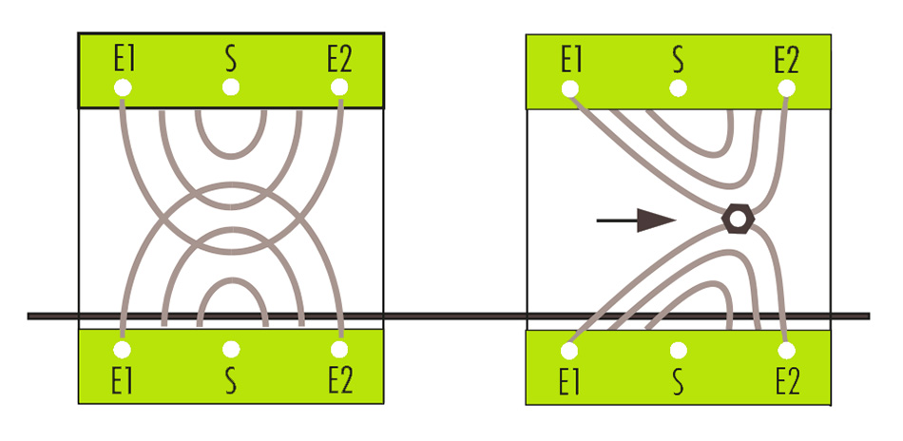

Basically there are several types of metal detectors that operate with different detection methods. In the food industry, metal detectors usually apply the transmitter-receiver method (see graphic).

Such metal detectors are equipped with a transmitter coil and two receiver coils. The transmitter coil generates a constant electromagnetic field. When a metal particle passes the detector it interferes with the electromagnetic field, causing a signal to be detected by the receiver coils. The electronic unit in the metal detector analyses this signal, evaluates it and signals a metal contamination. As a rule metal detectors in the food industry are equipped with automatic reject units that directly separate the contaminated product from the production line.

## Where are metal detectors installed in the food production process?

When used for machinery protection, the metal detector is installed directly before the machine to be protected. If, as in most cases in the food industry, consumer protection is the goal, several inspection points are useful. An inspection of raw material has the advantage that metal particles are separated before they are broken up into smaller pieces which might be harder to detect. Inspections at critical control points (HACCPs) during the production process are recommended to notice machinery failures (such as broken blades) in time.

Consequently, food products in their final stage after packaging are inspected once again with a metal detector (or an X-ray system) to fully exclude contamination.

For optimal product protection an inspection of raw materials, of several critical control points, and a final inspection of the finished product are recommended.

Ardiuno uno

Arduino/Genuino Uno is a microcontroller board based on the ATmega328P ([datasheet](http://www.atmel.com/Images/doc8161.pdf)). It has 14 digital input/output pins (of which 6 can be used as PWM outputs), 6 analog inputs, a 16 MHz quartz crystal, a USB connection, a power jack, an ICSP header and a reset button. It contains everything needed to support the microcontroller; simply connect it to a computer with a USB cable or power it with a AC-to-DC adapter or battery to get started.. You can tinker with your UNO without worring too much about doing something wrong, worst case scenario you can replace the chip for a few dollars and start over again.

"Uno" means one in Italian and was chosen to mark the release of Arduino Software (IDE) 1.0. The Uno board and version 1.0 of Arduino Software (IDE) were the reference versions of Arduino, now evolved to newer releases. The Uno board is the first in a series of USB Arduino boards, and the reference model for the Arduino platform; for an extensive list of current, past or outdated boards see the Arduino index of boards.

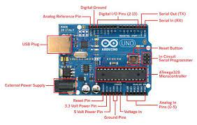

Inductive proxymetive sensor

An inductive proximity sensor is a non-contact [electronic](https://en.wikipedia.org/wiki/Electronics) [proximity sensor](https://en.wikipedia.org/wiki/Proximity_sensor). It is used for positioning and detection of metal objects. The sensing range of an inductive switch is dependent on the type of metal being detected. Ferrous metals, such as iron and steel, allow for a longer sensing range, while nonferrous metals, such as aluminum and copper, may reduce the sensing range by up to 60 percent.[[2]](https://en.wikipedia.org/wiki/Inductive_sensor#cite_note-Lamb-2)

Since the output of an inductive sensor has two possible states, an inductive sensor is sometimes referred to as an **inductive proximity switch**.[[2]](https://en.wikipedia.org/wiki/Inductive_sensor#cite_note-Lamb-2)[[3]](https://en.wikipedia.org/wiki/Inductive_sensor#cite_note-machine_design-3)

The [sensor](https://en.wikipedia.org/wiki/Sensor) consists of an [induction loop](https://en.wikipedia.org/wiki/Induction_loop) or detector coil. Most often this is physically a number of turns of insulated magnet wire wound around a high magnetic permeability core, such as a ferrite ceramic rod or coil form, and the winding may or may not have a feedback tap some number of turns from one end of the total winding. It is connected to a capacitance to form a tuned frequency oscillator tank circuit. In conjunction with a voltage or current gain device like a transistor or operational amplifier, this forms a tuned frequency oscillator. When power is applied, the resulting oscillation is a high frequency [alternating electric current](https://en.wikipedia.org/wiki/Alternating_current) in the coil that has a constantly changing [magnetic field](https://en.wikipedia.org/wiki/Magnetic_field) able to induces eddy currents in proximal (target) conductors. The closer the target is and the greater its conductivity (metals are good conductors, for example), the greater the induced eddy currents are and the more effect their resulting opposing magnetic fields have on the magnitude and frequency of the oscillation. Its magnitude is reduced as the load is increased in a non-magnetic conductor like aluminum because the induced field in the target opposes the source induction field, lowering net inductive impedance and therefore simultaneously tuning the oscillation frequency higher. But that magnitude is less affected if the target is a highly magnetically permeable material, like iron, as that high permeability increases the coil inductance, lowering the frequency of oscillation.

A change in oscillation magnitude may be detected with a simple amplitude modulation detector like a diode that passes the peak voltage value to a small filter to produce a reflective DC voltage value, while a frequency change may be detected by one of several kinds frequency discriminator circuits, like a phase lock loop detector, to see in what direction and how much the frequency shifts. Either the magnitude change or the amount of frequency change can serve to define a proximity distance at which the sensors go from on to off, or vice versa.

VI. CONCLUSION

In this paper, we proposed a Active Teaching method for robotic arm for food industry . and the use this arm as a metal sorting device The robotic arm will repeat the same action accordingly. An additional filter can installed for adding effects. This project will provide a wireless module to enable wireless control of the robotic arm via developed handheld controller to record action & convert them into devised motion codes and viceversa.